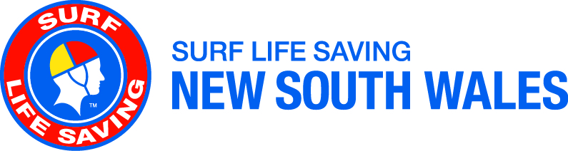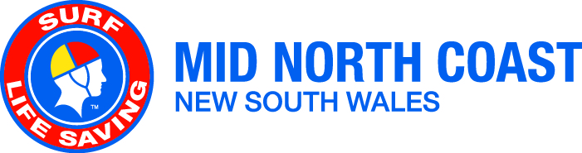

2020/2021 Junior Lifesaver of the Year Program and Award

Attention: JACs, Club Presidents and Executive, U14 members
Actioned by: JACs, Club Presidents and Executive, U14 members

Date: 1 December 2020
SLSMNC Gary Hawkins, SLSMNC Director of Member Services
Contact: Phone: 0403 135 833
Email: memberservices@slsmnc.com.au

Summary | This circular details the nomination process for the SLSMNC & SLSNSW Junior Lifesaver of the Year Program and Award.
Action | 2.5 Encourage and promote recognition of volunteers efforts to the wider community and external stakeholders

Surf Life Saving Mid North Coast (SLSMNC) is seeking nominations for the 2020/2021 SLSMNC Newcastle Permanent Junior Lifesaver of the Year Award.

The Junior Lifesaver of the Year Award is a way for Clubs and Branches to recognise their U14 members’ achievements in Surf Life Saving; the contributions they have made to all levels of Surf Life Saving as well as within the community.

The Junior Lifesaver of the Year Program aims to focus on recognising and rewarding the young members who have been selected as Branch Finalists. The program for this age group focuses on self-leadership, socialisation, teamwork, surf lifesaving and self-awareness. Participants will be involved in physical challenges, presentations and discussions, activities and scenarios that require leadership, teamwork and communication.

All U14 members who believe they could be the next Junior Lifesaver of the Year should apply through their Clubs. The male and female Club winners will then progress to the Branch Interview process. Branch winners will then progress to the SLSNSW development camp and interview process to determine the State winners.

The Award
Clubs are invited to submit one female and one male nomination for the 2020/2021 SLSMNC Junior Lifesaver of the Year Award. Nominations must include the attached nomination form, medical and consent form, and responses to the nomination questions.

Individual and club nominations are to be submitted to Branch in accordance with the timelines advised below.
Please note:
- All applications must be typed; handwritten applications will not be accepted.
- Nominees must have completed their Surf Rescue Certificate (SRC) at the time of the Junior Lifesaver of the Year Program to be eligible for the Junior Lifesaver of the Year Award.
- Resumes or additional information will not be considered by the judges and should not be included with nominations.

The criteria for selection will be based on the nominee’s achievements in the following areas:
- Contribution to Surf Life Saving
- Promotion of Surf Life Saving to the community
- Peer leadership
- Surf lifesaving knowledge and skills

All nominations are to be endorsed by Clubs and submitted to SLSMNC via email to memberservices@slsmnc.com.au by 9am Saturday 16 January 2021.

SLSMNC Branch interviews will be held Saturday 30 January 2021 at the Branch Office 13 Central Rd Port Macquarie. Interview times will be advised after nominations close.

Successful applicants will be advised of their placing as Branch finalists and are then required to attend the Junior Lifesaver of the Year Program held at The Collaroy Centre on Sydney’s Northern Beaches from Monday 12th to Wednesday 14th April 2021.

The Program
The program aims to further develop members by supporting personal development and goal setting, and by positively recognising members. Best of all, it is an opportunity to meet young surf lifesavers from across New South Wales and be part of a fun experience.

The program will be held at The Collaroy Centre in Sydney, where participants will be interviewed by a judging panel of experienced surf lifesavers, considering individuals on their merit to become the Junior Lifesaver of the Year.

Please note: SLSNSW will cover costs of accommodation, meals and activities for those members attending the workshop. Flights to and from the program will be covered by SLSNSW for finalists from FNC, NC, MNC and FSC, and as required for LNC and SC. Finalists from other branches will be required to organise their own transport. Further information regarding transport arrangements will be available once Branch finalists have been selected and provided to SLSNSW.

The announcement of the SLSNSW Junior Lifesavers of the Year will be at the completion of the program, around midday on Wednesday 14th April 2021. Parents are invited to join the award ceremony via livestream from the SLSNSW Facebook page, and more information will be shared closer to the date. Celebrations will be held at the program; State winners will not be attending the SLSNSW Awards of Excellence.

Further Information
If you have any questions about the Surf Life Saving NSW Junior Lifesaver of the Year Program and Award, please contact Gary on 0403 135 833 or memberservices@slsmnc.com.au
Nomination Form
2020/2021 Junior Lifesaver of the Year

Participant Details
Branch |  | Club
Full Name
Date of Birth |  | Gender | Female Male Indeterminate
Participant’s Email Address |  | Parent’s  Email Address
Mobile Number |  | Shirt Size | XS S M L XL XXL

Emergency Contact Details
Name | Relationship | Mobile Phone Number

Travel Details
What mode of transport do you intend to use to get to the program? | Car Bus Train Plane
Please complete the following if you will be flying
Which airport will you depart from?
Are there other details we need to know before booking your flights?
Please note: Flight details are non‐negotiable unless in an emergency. If you have any specific requests, please inform us immediately. Your commitment to this is important. Any ‘no shows’ or cancellations by participants will require full payment of all incurred expenses by that participant.

Club Endorsement
CLUB NAME
CLUB CONTACT | Name |  | Signature
 | Position |  | Date

Branch Endorsement
BRANCH NAME
BRANCH CONTACT | Name |  | Signature
 | Position |  | Date

Medical and Consent Form
2020/2021 Junior Lifesaver of the Year

SPECIAL REQUIREMENTS
Please identify any special needs or requirements (e.g. wheelchair access, food allergies etc.)

MEDICAL INFORMATION
Do you suffer from any medical conditions? (e.g. allergies, epilepsy, asthma, diabetes etc.)
Do you require medication for this condition?
If yes to either question – please give details (attach sheet if required)

RISK WAIVER
In the case of an emergency, I authorise the program staff where it is impractical to communicate with me, to arrange for me to receive such medical or surgical treatment as may be deemed necessary.

I understand that although Surf Life Saving NSW and its service providers attempt to minimise any risk of personal injury within practical boundaries, accidents do happen and all physical activities carry the risk of personal injury. I acknowledge and accept that there is an inherent risk of personal injury in physical activities that will be undertaken as part of the program.

Participant’s Signature Parent / Guardian Signature Date

MEDIA CONSENT
I agree to allow Surf Life Saving NSW to use my name and any photographs, sound and film recordings taken of me at this program for the promotion of the organisations services and initiatives to the media and the general public.

Participant’s Signature Parent / Guardian Signature Date

Privacy Statement
Surf Life Saving NSW, PO Box 307, Belrose NSW 2085 will collect and store the information you voluntarily provide to enable processing of enrolments for programs. The information will be provided to staff of the program and their facilitators where necessary and by providing this information you consent to this disclosure. Any information provided by you will be stored on a database that will only be accessed by authorised personnel and is subject to privacy restrictions. Any information provided by you to the organisation can be accessed by you during standard office hours, and updated by writing to us or by contacting us on 02 9471 8000.

SURF LIFE SAVING AUSTRALIA CODE OF CONDUCT
The Code of Conduct outlines the standard of conduct expected of all members. As a participant at this program, you agree to meet the following requirements in regard to your conduct during the program (including both formal and informal activities).
1. Respect the rights, dignity and worth of others
2. Be fair, considerate and honest in all dealings with others, and be a positive role model
3. Make a commitment to providing quality service
4. Be aware of, and maintain an uncompromising adhesion to, SLSA standards, rules, regulations and policies
5. Demonstrate a high degree of individual responsibility, especially when dealing with persons under 18 years of age
6. Contribute to the provision of a safe environment for the conduct of all activities within surf lifesaving
7. Ensure that your actions are of the highest standard at all times, and that, at no time, will your conduct be construed as bringing SLSA or SLSNSW into disrepute

Further, you agree to:
a. abide by the code of conduct outlined above
b. maintain a ‘duty of care’ towards others and an accountability for matters relating to the program
c. foster a collaborative approach to the program and its activities
d. accept responsibility for your personal learning and that of the group
e. be a positive role model for surf lifesavers and SLSA

Participant’s Signature Parent / Guardian Signature Date

Nomination Questions
2020/2021 Junior Lifesaver of the Year

NOMINATION QUESTIONS
- How long have you been involved in Surf Life Saving and what has been the highlight of your involvement so far?
- What personal Surf Life Saving achievements are you most proud of?
- Who inspires you to achieve your goals in Surf Life Saving?
- What do you think is the most important area or activity with Surf Life Saving and detail why?
- If you could initiate one program at Club, Branch or State level what would it be and why?

