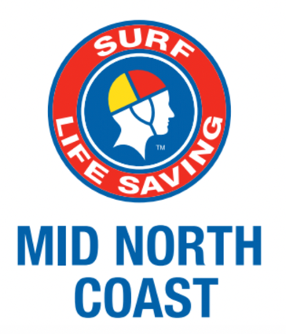

Annual General Meeting
Surf Life Saving Mid North Coast Inc.
Nomination Form - 2022

Name of position ___________________________________________
undersigned being financial members of an affiliated club hereby nominate
Name of member ___________________________________________
For the above position of Surf Life Saving Mid North Coast Inc. for the 2022/23 season
Nominated by: | Signature: | Club:
 |  | Date: / /2022
Seconded by: | Signature: | Club:
 |  | Date: / /2022

I, ___________________________________, being a financial member of ______________________ SLSC
accept the nomination for the position of ________________________________________ of the Surf Life
Saving Mid North Coast Branch Inc. for the 2022/23 season.
Print Name: | Signature: | Date:
