Notice - Annual General Meeting 2022
Notice is hereby given that an Annual General Meeting of Surf Life Saving Mid North Coast Inc. will be held at the SLSNSW Branch Office, Central Road, Port Macquarie on Monday 15th August 2022 commencing at 7pm.
- Opening of meeting
- Acknowledgement of Country
- Minutes Silence
- Club Affiliations and Accreditation of Delegates
- Apologies
- Proxies - Notification is to be made formally in writing on club letterhead endorsed by the club President.
- Adoption of Minutes of the 2021 AGM
- Business arising from 2021 AGM minutes
- Presentation of Annual Reports
- Presentation of Annual Financial Reports
- Notices of Motion:
  - That the Branch formally affiliates with Surf Life Saving New South Wales and Surf Life Saving Australia Ltd and further that the Branch agrees to abide by the Constitutions, Rules and Regulations and Policies, and resolutions of Surf Life Saving New South Wales and Surf Life Saving Australia Ltd.
- Election of Officers – President, Director of Finance, Director of Education, Director Surf Sports, Director of Member Services – 2-year term
- Appointment of auditor
- General Business of which due notice has been given
- Close of business
Club Compliance Requirements
- In order for Clubs to be compliant with Surf Life Saving New South Wales (SLSNSW), Surf Life Saving Australia (SLSA) and Surf Life Saving Mid North Coast (SLSMNC), each Club is required to complete an Affiliation Form and pay the prescribed fee prior to, or at the AGM. Annual Reports and Surf Club Audited Financials must be submitted by the due dates with a copy provided to SLSMNC.
- By affiliating with SLSNSW, Clubs and Branches agree to abide by the Constitution and Regulations of SLSNSW and SLSA. Affiliation to SLSNSW entitles Clubs and Branches to many benefits such as formal recognition as a Surf Life Saving Club, members insurance through Work Cover and members’/Clubs’ Public Liability Insurance.
- Affiliation Fee of $200 + GST = $220 Total per Club
Please note: If either of the above is not received by the Branch, then that Club waives the right of voting until such is received.
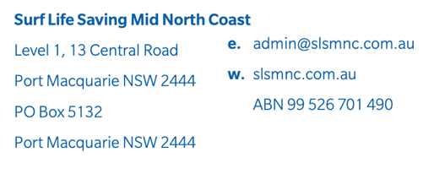
- If Clubs or Branches do not meet the Compliancy Requirements by the due dates, they will not receive fundraising distributions at the end of the year nor be eligible to apply for grants that require the endorsement of SLSNSW.

